
PATUAKHALI SCIENCE AND TECHNOLOGY UNIVERSITY
COURSE CODE CCE-211

SUBMITTED TO:

Prof. Dr. Md Samsuzzaman

Department of Computer and Communication Engineering
Faculty of Computer Science and Engineering

SUBMITTED BY:
Md. Sharafat Karim
ID: 2102024,
Registration No: 10151
Faculty of Computer Science and Engineering

Date of submission: 8 September 2024
Assignment 05
Assignment title: Chapter 07 (Transmission Medium)

Chapter 7 | Quizzes

What is the position of the transmission media in the OSI or the Internet model?
Below the physical layer.

Name the two major categories of transmission media.
Guided (wired) and unguided (wireless)

How do guided media differ from unguided media?
Guided medias offer a specific path from one device to another but unguided media doesn’t. In unguided media signal distributes through all direction.

What are the three major classes of guided media?
Twisted, Co-axical and Fiber optics.

What is the function of the twisting in twisted-pair cable?
To reduce noise.

What is refraction? What is reflection?
Refrection: If a ray of light traveling through one substance suddenly enters another substance (of a different density), the ray changes direction. It is known as refraction.
Reflection: If the angle is greater than the critical angle, the ray reflects (makes a turn) and travels again in the denser substance, which is known as reflection.

What is the purpose of cladding in an optical fiber?
Cladding has less density than the core, which helps to reflect the light. So it helps to transmit the signal.

Name the advantages of optical fiber over twisted-pair and coaxial cable.
Fiber optic has higher bandwidth, less signal attenuation, immune to electromagnetic interferences as well as lightweight.

How does sky propagation differ from line-of-sight propagation?
In sky propagation, higher-frequency radio waves radiate upward into the ionosphere (the layer of atmosphere where particles exist as ions) where they are reflected back to earth. This type of transmission allows for greater distances with lower output power.
In line-of-sight propagation, very high-frequency signals are transmitted in straight lines directly from antenna to antenna. Antennas must be directional, facing each other, and either tall enough or close enough together not to be affected by the curvature of the earth. Line-of-sight propagation is tricky because radio transmissions cannot be completely focused.

What is the difference between omnidirectional waves and unidirectional waves?
Omnidirectional waves send signals in all directions where unidirectional waves only transmits into a single path.
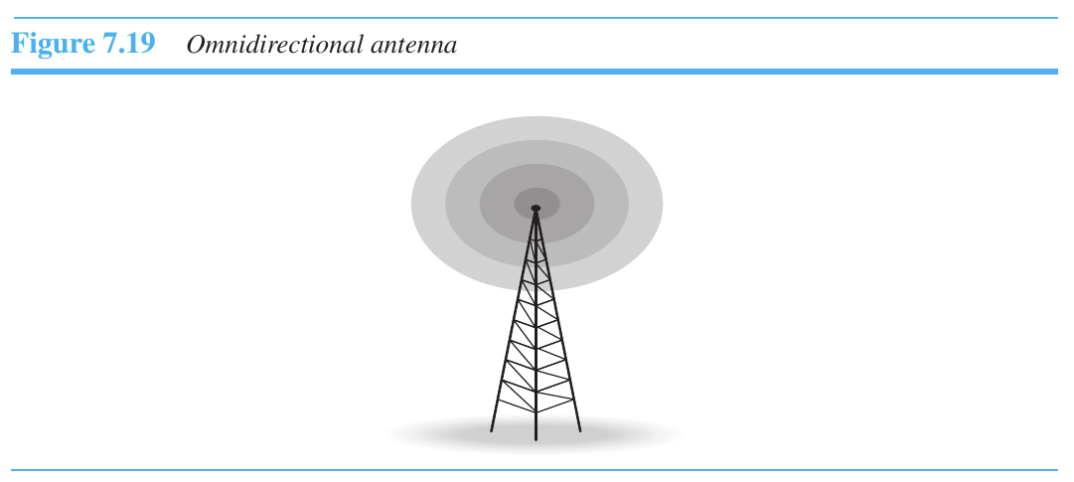
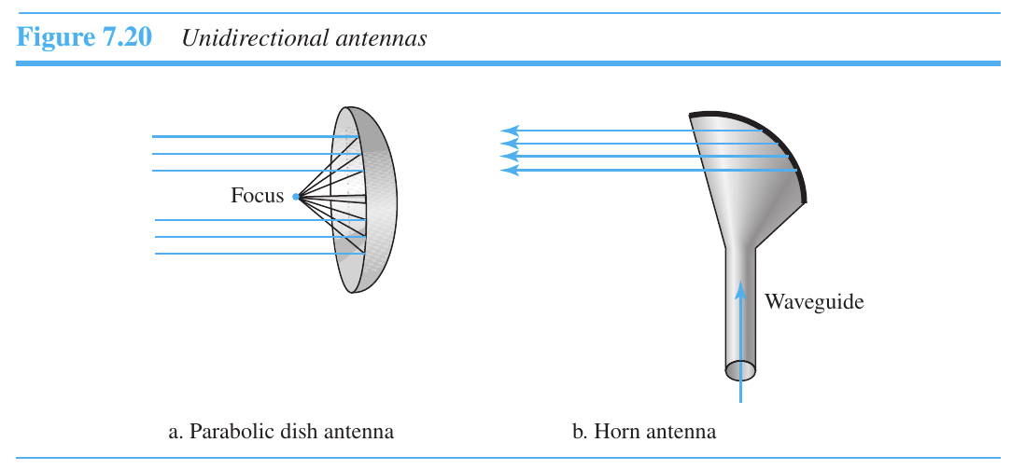

Chapter 7 | Problems

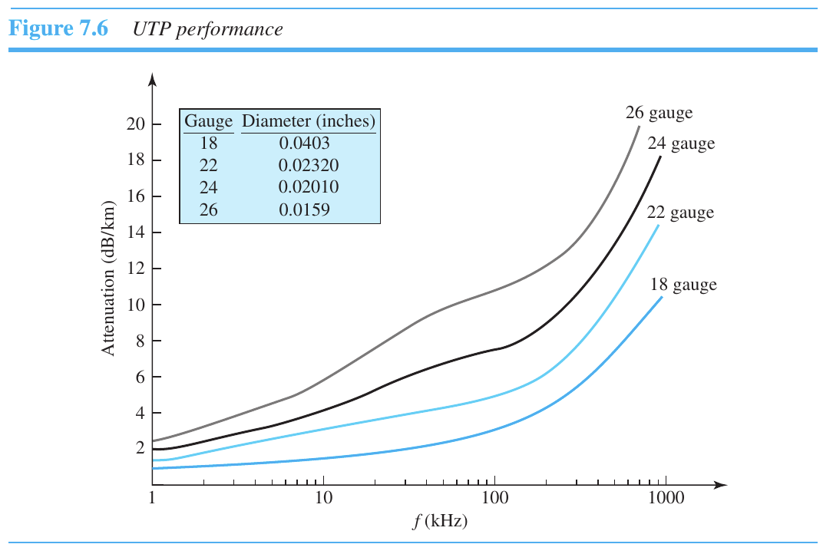
Using Figure 7.6, tabulate the attenuation (in dB) of a 18-gauge UTP for the indicated frequencies and distances.
Distance | dB at 1 KHz | dB at 10 KHz | dB at 100 KHz
1 km | 1.5 | 1.75 | 2
10 km | 15 | 17.5 | 20
15 km | 22.5 | 26.25 | 30
20 km | 30 | 35 | 40
These values are taken directly from image, so no absolute answer!

Use the results of Problem P7-1 to infer that the bandwidth of a UTP cable decreases with an increase in distance.
The more the distance is, the more bandwidth decreases. Explain yourself….

If the power at the beginning of a 1 Km 18-gauge UTP is 200 mw, what is the power at the end for frequencies 1 KHz, 10 KHz, and 100 KHz? Use the results of Problem P7-1.
We know that,
or,
For, 1KHz, (‘-’ve? Cause it’s decreasing? IDK)
Do the same for the rest...

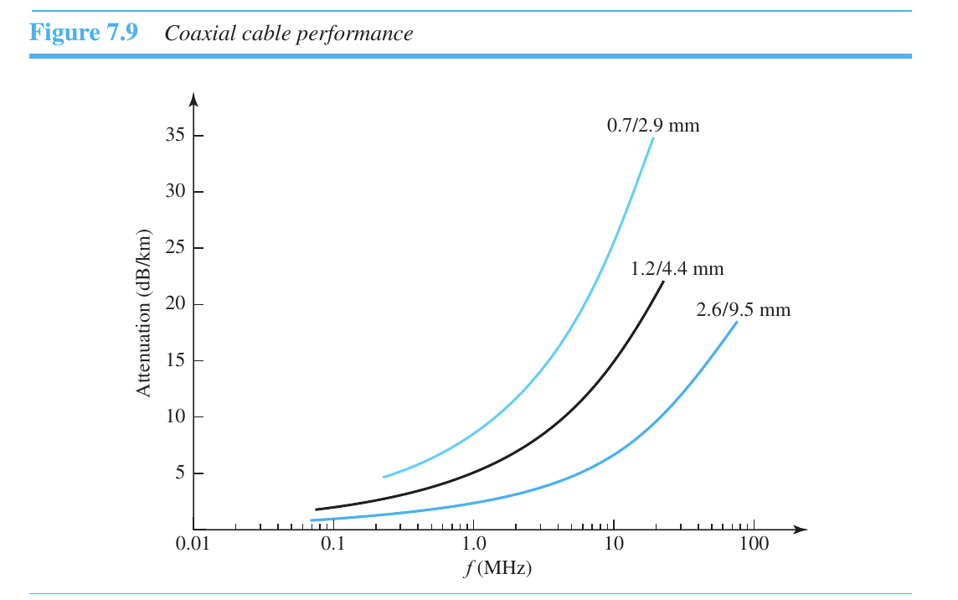
Using Figure 7.9, tabulate the attenuation (in dB) of a 2.6/9.5 mm coaxial cable for the indicated frequencies and distances.
Distance | dB at 1 KHz | dB at 10 KHz | dB at 100 KHz
1 km | 0 | 0.1 | 1
10 km
15 km
20 km
Not sure about it, Fill up the rest.

Use the results of Problem P7-4 to infer that the bandwidth of a coaxial cable decreases with the increase in distance.
Check 2

If the power at the beginning of a 1 Km 2.6/9.5 mm coaxial cable is 200 mw, what is the power at the end for frequencies 1 KHz, 10 KHz, and 100 Khz? Use the results of Problem P7-4.
Check 3

Calculate the bandwidth of the light for the following wavelength ranges (assume a propagation speed of 2 × 108 m):
a. 1000 to 1200 nm
b. 1000 to 1400 nm
with, f = c / λ
(a) bandwidth =
(b) try yourself!

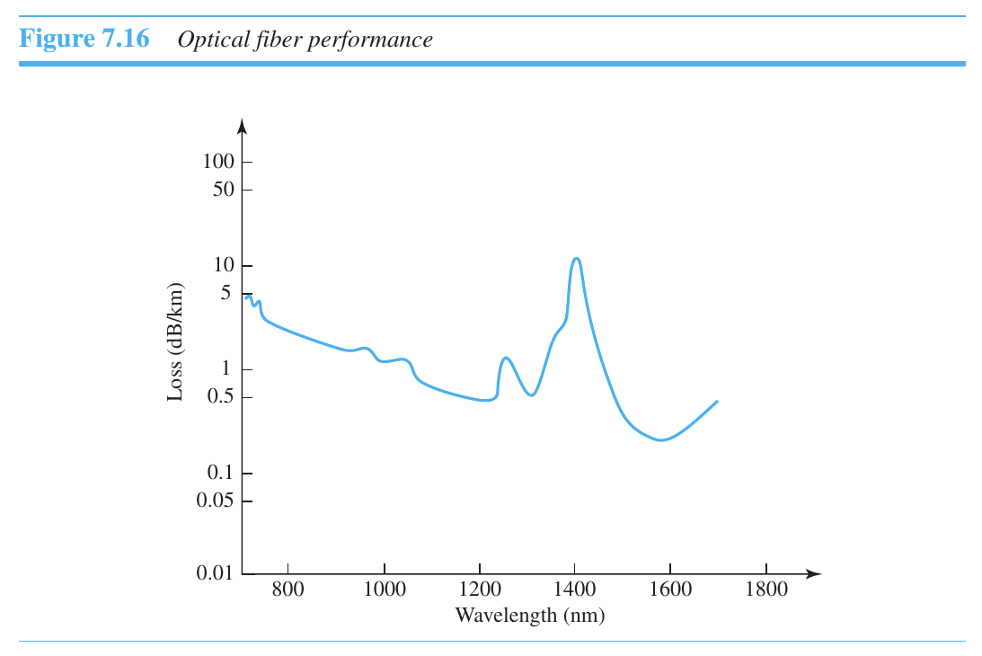
The horizontal axes in Figures 7.6 and 7.9 represent frequencies. The horizontal axis in Figure 7.16 represents wavelength. Can you explain the reason? If the propagation speed in an optical fiber is 2 × 108 m, can you change the units in the horizontal axis to frequency? Should the vertical-axis units be changed too? Should the curve be changed too?
  - Here frequency and wavelength are opposite (f = c / λ ), but they are basically same thing.
  - So we can change the units in horizontal axis, but we don’t necessarily need to change the vertical-axis.
  - The curve will be flipped horizontally in this case.

Using Figure 7.16, tabulate the attenuation (in dB) of an optical fiber for the indicated wavelength and distances.
Distance | dB at 800 nm | dB at 1000 nm | dB at 1200 nm
1 km | 3 | 1.1 | 0.5
10 km | 30
15 km | 45
20 km | 60
Not sure about it, Fill up the rest.

A light signal is traveling through a fiber. What is the delay in the signal if the length of the fiber-optic cable is 10 m, 100 m, and 1 Km (assume a propagation speed of 2 × 108 m)?

For 10 m,
Delay = 10 / 2 x 10^8 = 0.0000001
For 100 m,
Delay = 100 / 2 x 10^8 = 0.000001
For 100 m,
Delay = 10 / 2 x 10^8 = 0.0000001

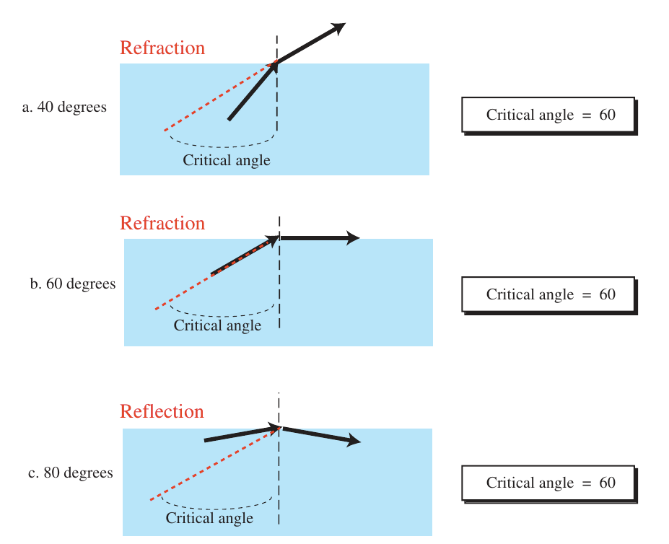
A beam of light moves from one medium to another medium with less density. The critical angle is 60°. Do we have refraction or reflection for each of the following incident angles? Show the bending of the light ray in each case.
  - 40
  - 60
  - 80

